Loading the web app



Time taken to load web app content from web browser and the time for server to process GET request





Navigating to blog page of web app (**page where memcached is used**)

Time taken to load web app content from web browser and for the server to process GET request





Reloading the blog page (Kim’s Blog) and reviewing the time taken from web browser and server side when memcached server is running.



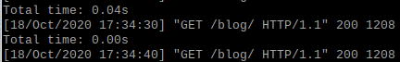





The first time loading took 330ms, the second time took 118ms. The server side log shows total time of 0.13s for the GET request for the first request and 0.04s for the second GET request. The third GET request shows 0.00s on the server side because memcached expires after 10 seconds for this test case. After the 10 seconds time window passes, the time to load the page is 227ms for the web browser.